Software Documentation

1. Software Overview
What does the software do?
This program acts as the main controller for the arcade machine. It sets a 45-second game timer as soon as it powers on. During those 45 seconds, it continuously reads 8 distinct buttons to drive four separate DC motors. It handles the complex "CoreXY" mixing required to drive the X and Y motors together for directional travel, controls a dedicated Z-axis motor for lifting/lowering, and controls a final motor to open and close the claw. Once the timer expires, it completely locks the system to end the game.
Platforms used:
MicroPython running on an ESP32 microcontroller.

2. System Logic
Initialize: The ESP32 assigns its pins, setting eight pins as button inputs (with internal pull-up resistors) and twelve pins as motor outputs (using PWM for speed control). It also starts a master game timer.
Timer Check: The code checks how much time has passed. If 45 seconds have elapsed, it triggers a "TIME UP" state, instantly stops all motors, and traps the code in a dead loop so no more buttons can be pressed.
Read XY Buttons (CoreXY): If the timer is still running, it checks the four directional buttons. If one is pressed, it sends full power to both Motor 1 and Motor 2 in specific forward/backward combinations to move the claw left, right, up, or down.
Read Z-Axis Buttons: It checks the dedicated Z-up and Z-down buttons. If pressed, it drives Motor 3 in the corresponding direction to raise or lower the claw string.
Read Claw Buttons: It checks the claw open and close buttons. If pressed, it drives Motor 4 to pinch or release.
Default Stop State: If you let go of a button, the code automatically sends a "zero speed" command to that specific motor, stopping its movement immediately.

3. Flowchart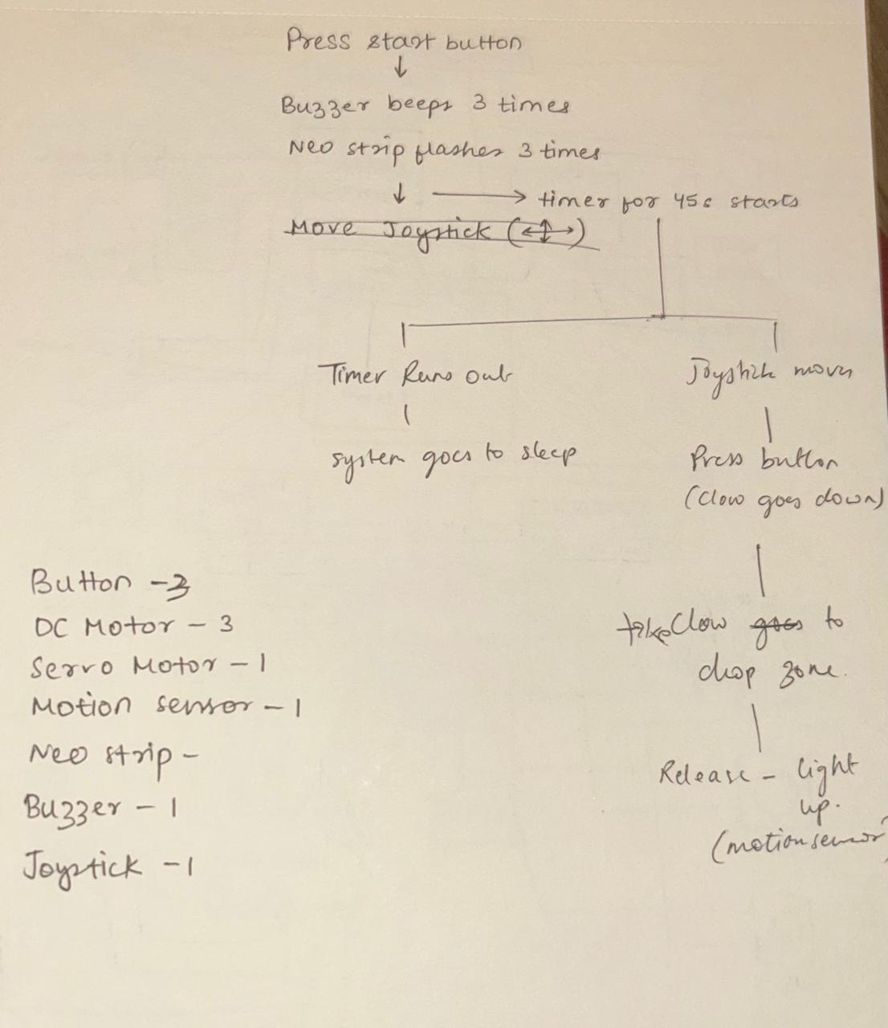
Visual representation of logic – Initial Idea – A few changes took place i.e. use of buttons instead of joystick, removal of motion sensor and replacement of servo motor with dc motor.

4. Code – Initial

CODE VERSION (INITIAL)

from machine import Pin, ADC, PWM

import neopixel

import time

pb3= Pin(18,Pin.IN,Pin.PULL_UP) #start button

pb2= Pin(4,Pin.IN,Pin.PULL_UP) #claw open and close button

#pb3= Pin(5,Pin.IN,Pin.PULL_UP) #claw up and down button

pb3_count= 0

last_pb3=1

claw_state = 0

last_pb2 = 1

xaxis = ADC(Pin(34)) #joystick

yaxis = ADC(Pin(35)) #joystick

sw= Pin(32,Pin.IN, Pin.PULL_UP) #joystick

xaxis.atten(ADC.ATTN_11DB) #joystick - how much voltage you can read

yaxis.atten(ADC.ATTN_11DB) #joystick - how much voltage you can read

xaxis.width(ADC.WIDTH_12BIT) #joystick - how accurately can you read the voltage

yaxis.width(ADC.WIDTH_12BIT) #joystick - how accurately can you read the voltage

np=neopixel.NeoPixel(Pin(21),16) #neopixel

#buzz = Pin(33, Pin.OUT) #buzzer

#servo= PWM(Pin(23),freq=50) #servo motor

DC1IN1 = Pin(26, Pin.OUT) #DC motor direction control - MOTOR 1 - X AXIS

DC1IN2 = Pin(27, Pin.OUT) #DC motor direction control - MOTOR 1 - X AXIS

en1 = PWM(Pin(14),freq=1000) #DC motor speed control- MOTOR 1 - X AXIS

DC2IN1 = Pin(25, Pin.OUT) #DC motor direction control- MOTOR 2 - Y AXIS

DC2IN2 = Pin(33, Pin.OUT) #DC motor direction control - MOTOR 2 - Y AXIS

en2 = PWM(Pin(32),freq=1000) #DC motor speed control- MOTOR 2 - Y AXIS

DC3IN1 = Pin(21, Pin.OUT) #DC motor direction control- MOTOR 3 - Z AXIS

DC3IN2 = Pin(22, Pin.OUT) #DC motor direction control - MOTOR 3 - Z AXIS

en3 = PWM(Pin(23),freq=1000) #DC motor speed control - MOTOR 3 - Z AXIS

st = 45000 #45 seconds

t= None #timer has not started yet

center_high = 2500 #joystick

center_low = 1500 #joystick

max_speed = 1023 #joystick 0-1023

def move_motor(in1, in2, en, dir, speed):

if dir == 1:

in1.value(1)

in2.value(0)

elif dir == -1:

in1.value(0)

in2.value(1)

else:

in1.value(0)

in2.value(0)

speed = 0

en.duty(speed)

while True:

pb1_val=pb1.value()

pb2_val=pb2.value()

pb3_val=pb3.value()

if pb1_val==0 and t is None: #start button pressed

time.sleep(0.3)

pb3_count=0

claw_state=0

print("GAME IS STARTING!!!")

for i in range(3): #buzzer sounds 3 times

buzz.value(1) #buzzer on

time.sleep(0.3)

buzz.value(0) # buzzer off

time.sleep(0.3)

print("45 second timer has STARTED!")

t=time.ticks_ms()#starting timer

time.sleep(0.3)

#CASE 1 : TIMER RUNS OUT

if t is not None:

if time.ticks_diff(time.ticks_ms(),t) >= st: #time taken is greater than 45s

print("TIME'S UP!!!")

for i in range(3):

buzz.value(1)

time.sleep(0.3)

buzz.value(0)

time.sleep(0.3)

move_motor(DC1IN1, DC1IN2, en1, 0, 0)

move_motor(DC2IN1, DC2IN2, en2, 0, 0)

move_motor(DC3IN1, DC3IN2, en3, 0, 0)

t= None

continue

#CASE 2 : TIME DOES NOT RUN OUT

x = xaxis.read()

y = yaxis.read()

if x > center_high:

move_motor(in1, in2, en1, 1, max_speed) # right

move_motor(in3, in4, en2, 1, max_speed) # down

elif x < center_low:

move_motor(in1, in2, en1, -1, max_speed) # left

move_motor(in3, in4, en2, -1, max_speed) # up

# ----- MOTOR 2 (Y AXIS) -----

elif y > center_high:

move_motor(DC1IN1, DC1IN2, en1, 1, max_speed) # right

move_motor(DC2IN1, DC2IN2, en2, -1, max_speed) # up

elif y < center_low:

move_motor(DC1IN1, DC1IN2, en1, -1, max_speed) # left

move_motor(DC2IN1, DC2IN2, en2, 1, max_speed) # down

else:

move_motor(DC1IN1, DC1IN2, en1, 0, 0)

move_motor(DC2IN1, DC2IN2, en2, 0, 0)

# if x > center_high: # X axis movement

# move_motor(DC1IN1, DC1IN2, en1, 1, 1023) # right

# print("right")

# elif x < center_low:

# move_motor(DC1IN1, DC1IN2, en1, -1, 1023) # left

# print("left")

# else:

# move_motor(DC1IN1, DC1IN2, en1, 0, 0)

#

# if y > center_high: # Y axis movement

# move_motor(DC2IN1, DC2IN2, en2, 1, 1023) # down

# print("down")

# elif y < center_low:

# move_motor(DC2IN1, DC2IN2, en2, -1, 1023) # up

# print("up")

# else:

# move_motor(DC2IN1, DC2IN2, en2, 0, 0)

if pb3_val==0 and last_pb3 == 1: # pb3 pressed

pb3_count = (pb3_count + 1) % 3 # toggles 0 - 1 -2 -0

time.sleep(0.2)

if pb3_count == 1:

move_motor(DC3IN1, DC3IN2, en3, 1, max_speed) # down

elif pb3_count == 2:

move_motor(DC3IN1, DC3IN2, en3, -1, max_speed) # up

else:

move_motor(DC3IN1, DC3IN2, en3, 0, 0)

last_pb3 = pb3_val #last status update

# CLAW OPEN AND CLOSE - SERVO MOTOR

if pb2_val == 0 and last_pb2 == 1:

claw_state = (claw_state + 1) % 2

time.sleep(0.2)

if claw_state == 0:

servo.duty(40) # open

else:

servo.duty(115) # close

last_pb2 = pb2_val

time.sleep(0.01)

5. Code – Final
from machine import Pin, PWM
import time

# BUTTONS
pb_left = Pin(12, Pin.IN, Pin.PULL_UP)
pb_right = Pin(4, Pin.IN, Pin.PULL_UP)
pb_down = Pin(5, Pin.IN, Pin.PULL_UP)
pb_up = Pin(18, Pin.IN, Pin.PULL_UP)

pb_z_up = Pin(35, Pin.IN, Pin.PULL_UP)
pb_z_down = Pin(16, Pin.IN, Pin.PULL_UP)

pb_claw_open = Pin(17, Pin.IN, Pin.PULL_UP)
pb_claw_close = Pin(19, Pin.IN, Pin.PULL_UP)

# MOTOR 1 (X)
in1 = Pin(26, Pin.OUT)
in2 = Pin(27, Pin.OUT)
en1 = PWM(Pin(14), freq=1000)

# MOTOR 2 (Y)
in3 = Pin(25, Pin.OUT)
in4 = Pin(33, Pin.OUT)
en2 = PWM(Pin(32), freq=1000)

# MOTOR 3 (Z)
in5 = Pin(21, Pin.OUT)
in6 = Pin(22, Pin.OUT)
en3 = PWM(Pin(23), freq=1000)

# MOTOR 4 (CLAW)
in7 = Pin(13, Pin.OUT)
in8 = Pin(15, Pin.OUT)
en4 = PWM(Pin(27), freq=1000)

# SETTINGS
max_speed = 1023
GAME_TIME = 45 # seconds

start_time = time.time()

def move_motor(in1, in2, en, direction, speed):
if direction == 1:
in1.on()
in2.off()
elif direction == -1:
in1.off()
in2.on()
else:
in1.off()
in2.off()
speed = 0
en.duty(speed)

def stop_all():
move_motor(in1, in2, en1, 0, 0)
move_motor(in3, in4, en2, 0, 0)
move_motor(in5, in6, en3, 0, 0)
move_motor(in7, in8, en4, 0, 0)

while True:
elapsed = time.time() - start_time

# TIME OVER
if elapsed >= GAME_TIME:
print("TIME UP - SYSTEM LOCKED")

stop_all()

# SYSTEM LOCKED
while True:
stop_all()
time.sleep(1)

# XY MOVEMENT
if pb_left.value() == 0:
move_motor(in1, in2, en1, -1, max_speed)
move_motor(in3, in4, en2, -1, max_speed)
print("left")

elif pb_right.value() == 0:
move_motor(in1, in2, en1, 1, max_speed)
move_motor(in3, in4, en2, 1, max_speed)
print("right")

elif pb_down.value() == 0:
move_motor(in1, in2, en1, 1, max_speed)
move_motor(in3, in4, en2, -1, max_speed)
print("down")

elif pb_up.value() == 0:
move_motor(in1, in2, en1, -1, max_speed)
move_motor(in3, in4, en2, 1, max_speed)
print("up")

else:
move_motor(in1, in2, en1, 0, 0)
move_motor(in3, in4, en2, 0, 0)

# Z AXIS
if pb_z_up.value() == 0:
move_motor(in5, in6, en3, 1, max_speed)
print("Z up")

elif pb_z_down.value() == 0:
move_motor(in5, in6, en3, -1, max_speed)
print("Z down")

else:
move_motor(in5, in6, en3, 0, 0)

# CLAW
if pb_claw_open.value() == 0:
move_motor(in7, in8, en4, 1, max_speed)
print("Claw opening")

elif pb_claw_close.value() == 0:
move_motor(in7, in8, en4, -1, max_speed)
print("Claw closing")

else:
move_motor(in7, in8, en4, 0, 0)

time.sleep(0.05)

Codes to test components -
Claw Code
from machine import Pin, PWM
import time

# L298N Motor Driver Setup
speed_pin = PWM(Pin(19))
speed_pin.freq(1000)

dir_pin_1 = Pin(13, Pin.OUT)
dir_pin_2 = Pin(15, Pin.OUT)

MOTOR_SPEED = 1023

# Main Loop
while True:

# Open claw
print("Opening Claw...")
dir_pin_1.value(1)
dir_pin_2.value(0)
speed_pin.duty(MOTOR_SPEED)
time.sleep(0.8)
dir_pin_1.value(0)
dir_pin_2.value(0)
speed_pin.duty(0)

time.sleep(2)

# Close claw
print("Closing Claw...")
dir_pin_1.value(0)
dir_pin_2.value(1)
speed_pin.duty(MOTOR_SPEED)
time.sleep(0.6)
dir_pin_1.value(0)
dir_pin_2.value(0)
speed_pin.duty(0)

time.sleep(2)

Test code for joystick and motors
from machine import Pin, PWM, ADC
import time

joy_x = ADC(Pin(34))
joy_y = ADC(Pin(35))
joy_x.atten(ADC.ATTN_11DB)
joy_y.atten(ADC.ATTN_11DB)

in1 = Pin(27, Pin.OUT)
in2 = Pin(26, Pin.OUT)
ena = PWM(Pin(14))
ena.freq(1000)

in3 = Pin(25, Pin.OUT)
in4 = Pin(33, Pin.OUT)
enb = PWM(Pin(23))
enb.freq(1000)

MIN_DUTY = 350
MAX_DUTY = 950

time.sleep(3)
center_x = joy_x.read()
center_y = joy_y.read()

while True:
raw_x = joy_x.read()
raw_y = joy_y.read()

x_val = 0.0 if abs(raw_x - center_x) < 200 else (raw_x - center_x) / (float(center_x) if raw_x < center_x else (4095.0 - center_x))
y_val = 0.0 if abs(raw_y - center_y) < 200 else -((raw_y - center_y) / (float(center_y) if raw_y < center_y else (4095.0 - center_y)))

a_mix = max(-1.0, min(1.0, y_val + x_val))
b_mix = max(-1.0, min(1.0, y_val - x_val))

duty_a = 0 if a_mix == 0.0 else int(MIN_DUTY + abs(a_mix) * (MAX_DUTY - MIN_DUTY))
duty_b = 0 if b_mix == 0.0 else int(MIN_DUTY + abs(b_mix) * (MAX_DUTY - MIN_DUTY))

if a_mix > 0:
in1.on(); in2.off()
elif a_mix < 0:
in1.off(); in2.on()
else:
in1.off(); in2.off()
ena.duty(duty_a)

if b_mix > 0:
in3.on(); in4.off()
elif b_mix < 0:
in3.off(); in4.on()
else:
in3.off(); in4.off()
enb.duty(duty_b)

time.sleep(0.1)

Code for joystick – picked from forum about PS2 joysticks.1
from machine import Pin, ADC
from time import sleep

# Joystick axes on ADC1 pins
x_axis = ADC(Pin(34)) # VRx
y_axis = ADC(Pin(35)) # VRy

# Set attenuation for full 0–3.3V range
x_axis.atten(ADC.ATTN_11DB)
y_axis.atten(ADC.ATTN_11DB)

# Joystick button on GPIO32
button = Pin(26, Pin.IN, Pin.PULL_UP)

print("Starting Joystick Check...")

while True:
x_val = x_axis.read()
y_val = y_axis.read()
z_val = button.value()
#print(f"X: {x_val:5} | Y: {y_val:5}")

print(f"X: {x_val:5} | Y: {y_val:5} | Button: {'Pressed' if z_val == 0 else 'Released'}")
sleep(0.2)

DC motor testing codes
from machine import Pin, PWM
import time

#Motor A
in1 = Pin(27, Pin.OUT)
in2 = Pin(26, Pin.OUT)
ena = PWM(Pin(14))
ena.freq(1000)
ena.duty(1023)

# Motor B
in3 = Pin(25, Pin.OUT)
in4 = Pin(33, Pin.OUT)
enb = PWM(Pin(23))
enb.freq(1000)
enb.duty(1023)

# # Motor C
# in5 = Pin(4, Pin.OUT)
# in6 = Pin(5, Pin.OUT)
# enc = PWM(Pin(2))
# enc.freq(1000)
# enc.duty(512)

while True:
# Motor A forward/back
in1.on(); in2.off()
# time.sleep(3)
# in1.off(); in2.on()
# time.sleep(3)
# in1.off(); in2.off() # stop motor A

# Motor B forward/back
in3.on(); in4.off()
# time.sleep(3)
# in3.off(); in4.on()
# time.sleep(3)
# in3.off(); in4.off() # stop motor B

# # Motor C forward/back
# in5.on(); in6.off()
# time.sleep(3)
# in5.off(); in6.on()
# time.sleep(3)
# in5.off(); in6.off() # stop motor C
Initial servo motor code
from machine import Pin, PWM
import time
moto =PWM(Pin(32))
moto.freq(50)
while True:
moto.duty(35)
time.sleep(0.2)
moto.duty(110) #0 degree = 18
time.sleep(0.2)

